|  |  |
| --- | --- |
| Date | 10 November 2022 |
| Team ID | PNT2022TMID05942 |
| Project Name | Project -Smart Waste Management System For Metropolitan Cities |

IBM WATSON IOT PLATFORM

Step 1: login into IBM CLOUD account

Step2: click on catalog and search for IOT platform

Step 3: Then search for IOT Watson platform then click on create

Step 4: Then click on add device and give the device type and necessary details then click finish

Step 5: Finally, IOT Watson platform is successfully created

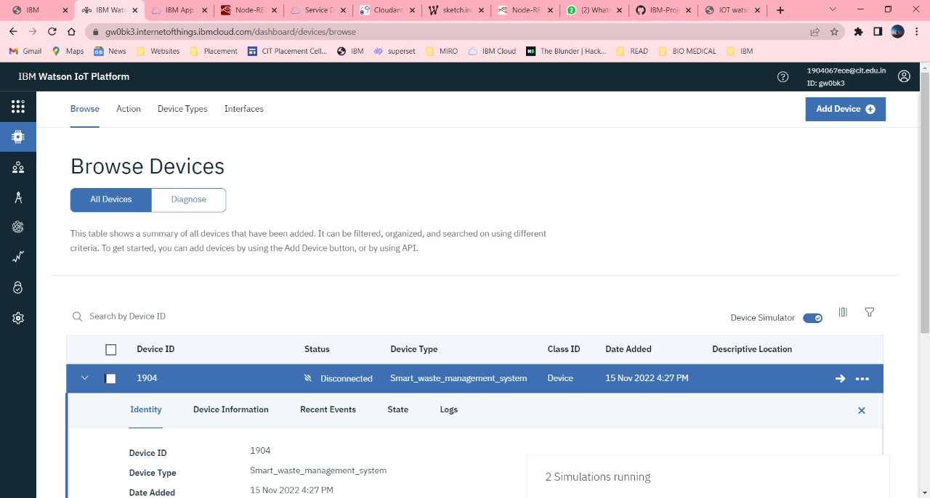

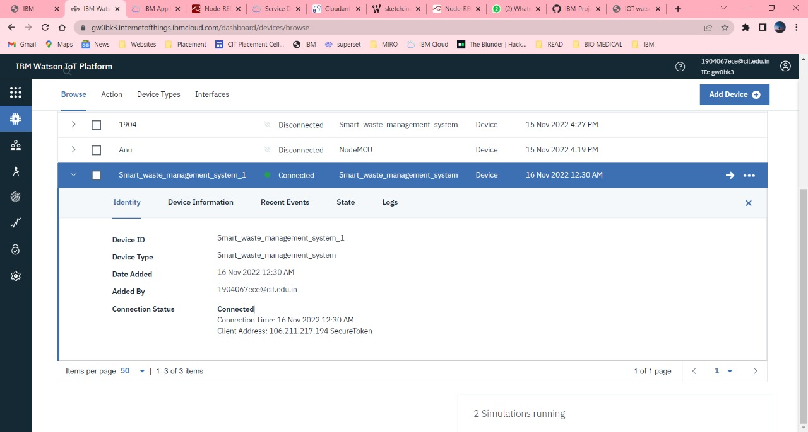

**Create a database in cloudant DB**

Step 1: login into IBM CLOUD account

Step2: On the top left corner click on RESORCE LIST

Step 3: Search for Database option then click on drop down arrow

Step 4: Then click on cloudant account available

Step 5: Now, cloudant window appears then click on launch dashboard on right corner

Step 6: click on create database on right corner then provide the name for database and check the -partitioned - recommended for most workloads>option then click on create

Step 7: Finally, cloudant DB was successfully created.

SCREENSHOTS OF CLOUDANT ACCOUNT:

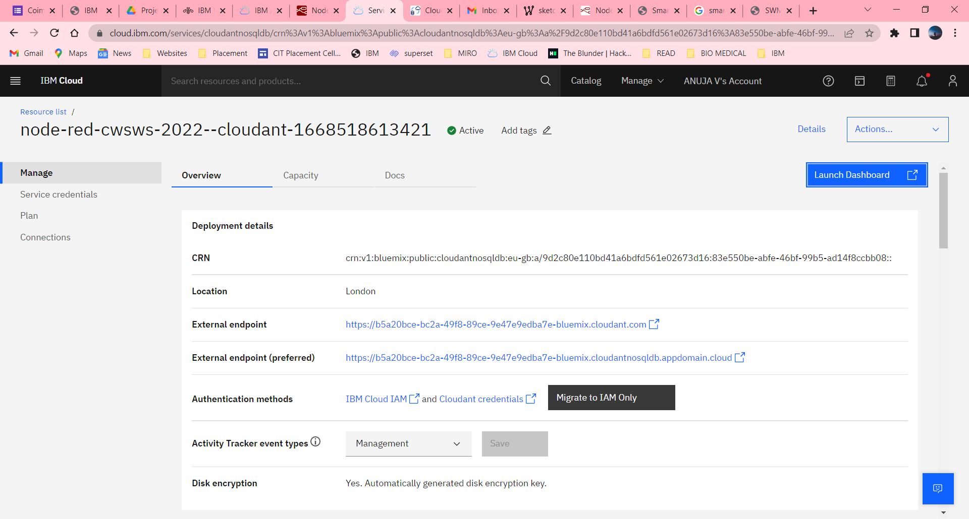

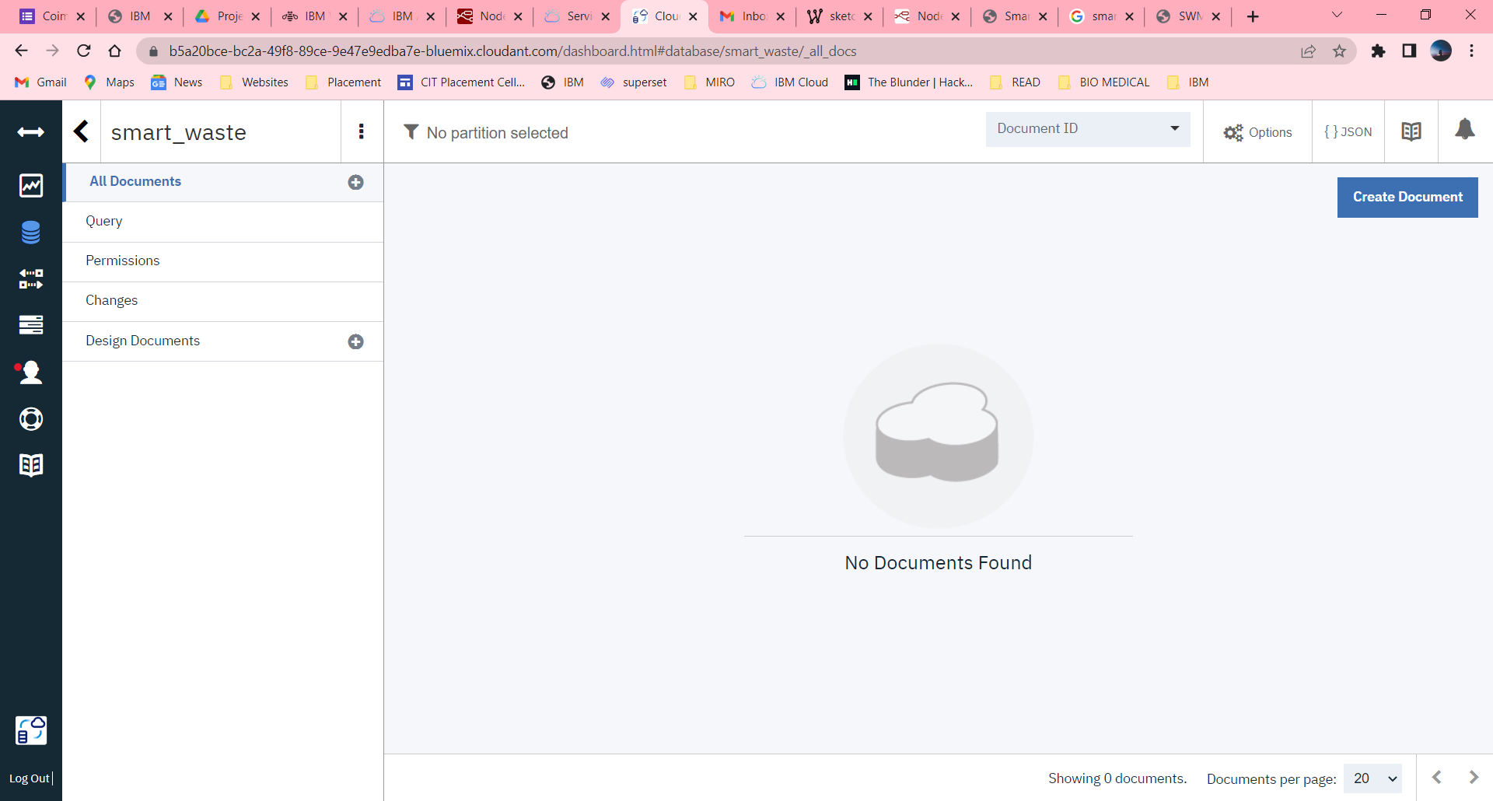

**NODE – RED PLATFORM**

